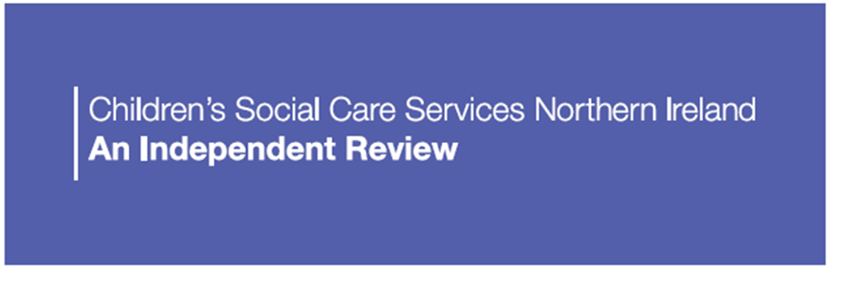

**MARCH 2022 NEWSLETTER**

The [Independent Review of Northern Ireland’s Children’s Social Care Services](https://www.health-ni.gov.uk/sites/default/files/publications/health/doh-cscsni-tor.pdf) was launched by Robin Swann, the Minister of Health, at the beginning of [February](https://www.health-ni.gov.uk/sites/default/files/publications/health/doh-cscsni-press-release.pdf) 2022.

The Review is being undertaken by [Professor Ray Jones](https://www.health-ni.gov.uk/sites/default/files/publications/health/doh-cscsni-review-team-bios.pdf) as the independent Lead Reviewer who will be assisted by an Advisory Panel and a Secretariat. It is planned that the Review will be completed within 16 months with the first 12 months of ‘fieldwork’ largely spent meeting with and listening to those involved with children’s social care across Northern Ireland.

**ADVISORY PANEL**

[Professor Pat Dolan](https://www.health-ni.gov.uk/sites/default/files/publications/health/doh-cscsni-review-team-bios.pdf), [Marie Roulston M.A. CQSW. O.B.E.](https://www.health-ni.gov.uk/sites/default/files/publications/health/doh-cscsni-review-team-bios.pdf) and [Her Honour Judge Patricia Smyth](https://www.health-ni.gov.uk/sites/default/files/publications/health/doh-cscsni-review-team-bios.pdf) have been appointed as the ‘standing members’ of the Advisory Panel, and the Advisory Panel has already had one meeting.

At all future meetings of the Advisory Panel (which are likely to be held every two months), two children / young people and two parents and carers will join the meeting as Panel members.

**CHILDREN, YOUNG PEOPLE, PARENTS AND CARERS**

The Voice of Young People in Care (VOYPIC) are undertaking a region-wide exercise to recruit to a Reference Group of children and young people who have personal experience of children’s social care services. The Reference Group will decide which two members will attend each of the Advisory Panel meetings.

Children in Northern Ireland (CiNI) are linking with existing groups and forums of parents and carers to arrange engagement with the Review and will identify two parents/ carers to attend meetings of the Advisory Panel. As with children and young people, it is intended that different parents/ carers will attend each Advisory Panel meeting to ensure that a breadth of experience and advice from parents/ carers is available to the Review.

In addition, opportunities across the region will be organised for children and young people, and for parents and carers to contribute to the Review and to meet with Ray Jones.

**SOCIAL CARE WORKERS, SERVICES AND PARTNERS**

Plans are already being made for Ray Jones to visit services, meet with social workers and other professionals, and with social care’s partner agencies across Northern Ireland.

Over the coming months Professor Jones will be visiting services across the region and meeting with front-line practitioners, managers and senior leaders in children’s social care services. He will also be seeking to meet with, amongst others, teachers, health workers, police officers, and those working within children’s social care services provided by independent, voluntary and community services.

This programme has already started. Professor Jones has had two days in the Western HSC Trust area meeting with frontline children’s social care teams, workers and managers and another two days in the Belfast HSC Trust area. In the Western HSC Trust area, there has been an initial meeting with a ‘parents’ forum and in both Trusts’ areas there have been visits to children’s homes. Initial two day visits are being arranged for visits to the remaining three HSC Trust areas.

During February and early March, Professor Jones has also had initial meetings with, for example, the Northern Ireland Public Service Alliance (NIPSA), the British Association of Social Workers – Northern Ireland (BASWNI), the Commissioner for Children and Young People (NICCY), the Regulation and Quality Improvement Authority (RQIA), the Public Health Agency (PHA), the Independent Chair of the Safeguarding Board for Northern Ireland (SBNI) and the Northern Ireland Guardian Ad Litem Agency (NIGALA) as well as VOYPIC and CiNI.

The programme of meetings and engagements will continue until February 2023 with many more organisations/professionals/groups/individuals to be invited to participate in the Review. For example, meetings/engagement events are being planned with foster carers and others who have had direct participation within children’s social care, with universities and their social work educators, researchers and students, and with the judiciary within the family courts.

If not already contacted or named in this Newsletter please do not feel or anticipate being ignored or excluded. This Newsletter has been prepared within the first few weeks of the Review and much more engagement is being planned and arranged for the coming months.

**OTHER IMMEDIATE ACTIVITIES**

The Secretariat which is supporting the Review’s activities is set to expand and recruitment is currently underway and our April Newsletter will include an update on progress.

We intend to have the Review’s website up and running by April. It will include information about how to contact the Review, key documents and latest news. The website will serve as a platform to connect with you and to seek your views. It is intended that there will be a range of ways in which to contribute to the Review and to share experiences and advice. In the meantime you can contact the Review Team by email at: [Contact@CSCSReviewNI.net](mailto:Contact@CSCSReviewNI.net).

Professor Jones and the Review Team very much look forward to engaging with you throughout the next twelve months and will continue to share news and updates on progress.